**Aim:**

To create the following table in SQL :

|  |  |  |  |  |  |  |
| --- | --- | --- | --- | --- | --- | --- |
| rollno | Name | cgpa | stream | grade | Class | section |
| 1 | Anand | 8.6 | Science | A | 12 | A |
| 2 | Harshit | 9.0 | Science | A | 12 | A |
| 3 | Siddharth | 8.0 | Commerce | B | 12 | C |
| 4 | Ritveek | 7.0 | Commerce | C | 12 | C |
| 5 | Amritanshu | 8.0 | Medical | D | 12 | B |
| 6 | Kshitiz | 8.0 | Science | A | 12 | A |
| 7 | Kunal | 8.0 | Medical | D | 12 | B |
| 8 | Rishab | 8.0 | Science | D | 12 | B |

**Table : hilwoods**

Q.Write SQL queries for the following commands.

1.To Create database Schoolfile

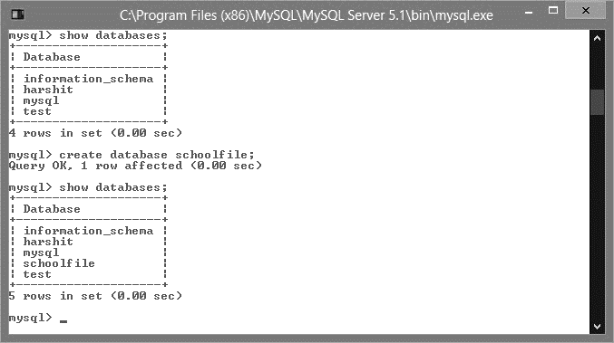

2. To Create Table Hillwoods

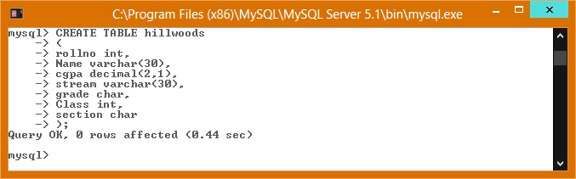

3. To insert record into table Hillwoods

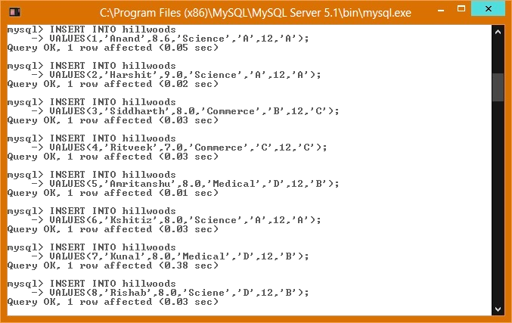

Displaying Table :

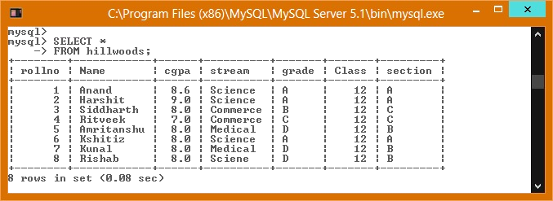

4. To Display records from table where stream is commerce

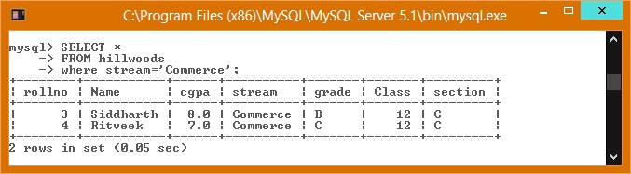

5. To Display records from table where Section is A and arrange them in order of CGPA

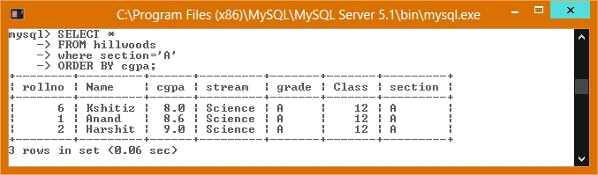

6. To Display all the Records of Table arranged in Acending order of CGPA

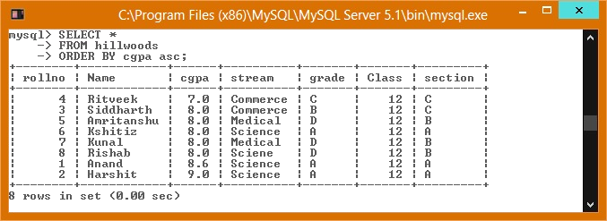

7. To Delete record from table where CGPA is less than 7.0

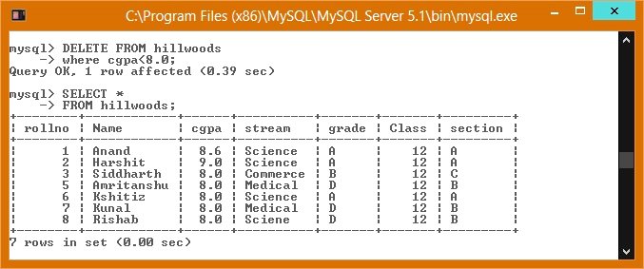

8. To Delete column Section from Table

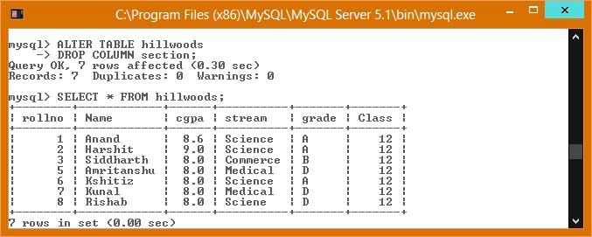

9. To Add column house to the Table

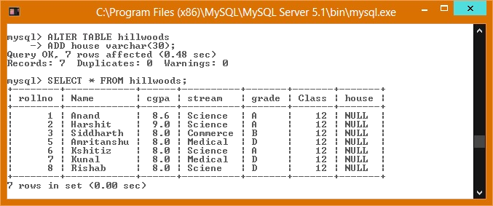

10.To rename column name cgpa to CGPA

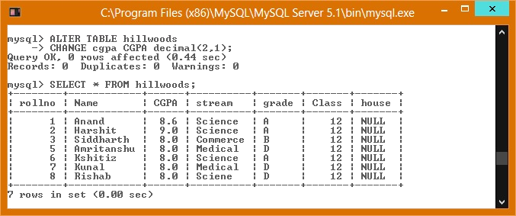

11.To Create rollno as Primary Key

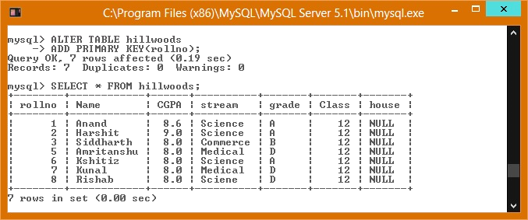

12.To Change the Datatype Defination of Name

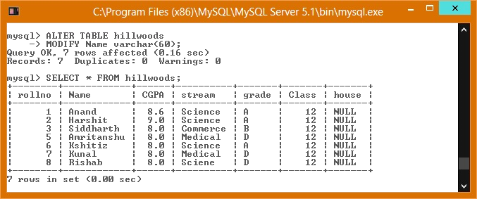

13.To Update a record with given details

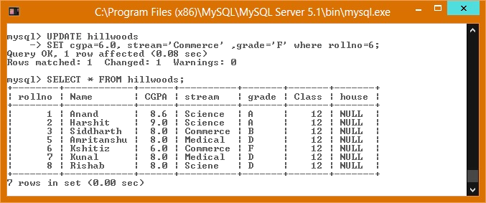

14 .To insert data into the house field of a particular record

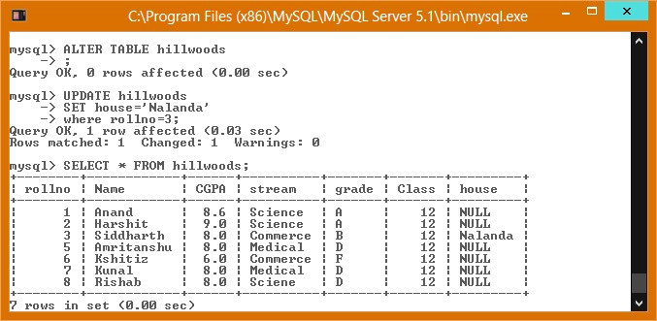

15.To Delete the Table

